Penguin Classification Report

Project Title: Penguin Classification
Course: STAT 692-XXX - Statistical Consulting
Student Name: Dustin Smith
Date Submitted: 06/16/2026

Reports are provided below:

To: Dr. Anya Sharma
From: Dustin Smith -- Statistical Consultant
Date: 06/16/2026
Subject: Statistical Classification of Palmer’s Penguins
1. Key Finding & Recommendation
Based on the available data, the preserved specimen is classified as a Gentoo penguin (Pygoscelis papua). The predictive model developed for classification, based on bill length (culmen) and flipper lengths, operates at a 96% accuracy. Indicating a high level of confidence for when classifying this particular specimen with a Culmen length of 45mm and flipper length of 220mm, and provides a high level of confidence in the choice of Gentoo penguin.
2. Supporting Visualization
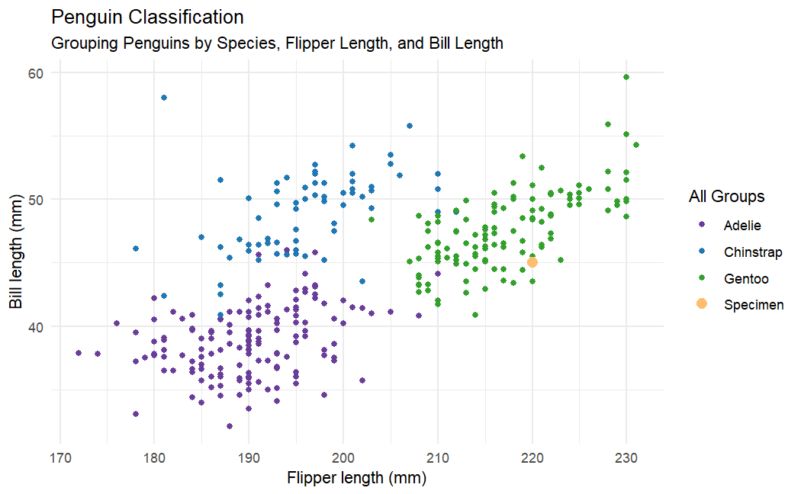
Figure 1: [Clustered groupings of penguin’s species, by flipper length and bill length. Note, the specimen is plotted in orange/yellow and is very well aligned within the Gentoo cluster]
3. Summary of Analysis
The data shows that there is a significant difference in each species of penguins based upon their biological indicators. While there is some overlap within the groups, in general the groups are very well separated. Particularly, the centers of Gentoo penguins is 47 bill length, and 217 flipper length. The values presented {45, 220} fit very nicely within the Gentoo grouping. With further predictive modeling, the separation in species can be articulated with formula allowing for separation of species with an accuracy of 96%.
Part 2: Technical Appendix (For Instructor Review)
2.1. Link to Reproducible Code
GitHub Link: https://github.com/dusmith0/Peguins
2.2. Analysis Justification
List of Required Justification
Question | Justification
Statistical Modeling Used | - Multi-class SoftMax Logistic Regression – For Classification  - MANOVA – For initial hypothesis testing Mean₁ = Mean₂ = Mean₃  - Shapiro-Wilks and QQ plots – For testing normality in the data (for both overall variable normality, within group normality, and joint normality.)  - Cross-Entropy Loss, Confusion matrices – for checking model reliability
Justification for Method: | Initially (linear discriminate analysis) was considered best. However, the normal assumptions were not met, and logistic regression was attempted instead. As there are three classes to work with, ordinary logit (binomial) modeling would not be sufficient, so the SoftMax was chosen to handle multiple classes. As the MANOVA statistic indicated significant difference within each grouping (F-statistics of 594 and 410), it was assumed that a logistic regress would be able to easily pick up the differing groups. The data was split into 80% training for model reliability, and Cross-Entropy loss resulted in .102, and the confusion matrix found only 3 of 68 tested data incorrectly classified.  Advanced classifiers such as random forests or XGboosting was deemed unnecessary for such a simple data set.
Assumptions Checked. | Normality was checked with QQ plots, Shapiro-Wilks, and Multivariate Shapiro-Wilks. This test found that the within group normality was not met for the Gentoo class (p-values of .002, and .013), and the multivariate normality failed in both the Gentoo (p-value of .02128) and Chinstrap (p-value of .00009).  Outliers were not observed in constructed Box-plots, histograms, or QQ plots. The sample sizes for each group were each larger then 50, so no changes would be needed for sparce data.  The overall flipper and bill data is correlated with a score of .65 (Pearson), resulting in extremely high VIF values. However, VIF may not be stable for multiclass regression. Looking further, the AIC of a model with both flipper and bill is 77.86 and misses 3 times out of 68. However, the bill only model has an AIC of 285 and misses the target 13 times while highly favoring “Gentoo”. The model with only flipper has an AIC of 245 and misses the target 9 times. Both models are dramatically worse than the original, even though some collinearity is likely present.

2.3. Personal Reflection
This practice project was quite simple to begin with. The data was clearly separated, make any valid classifier useful for the client’s objective. It was nice to have a real target to aim for. In may projects, we are either modeling, assessing how well or poorly a model fits, or assessing how violations can affect the model. In this project there was a defined goal. Being able to clearly define a path to that goal, and then achieve the goal was nice. The modeling, assessment checking, and model choice were quite simple and easy to do, being a classic logistic model. However, I do not have much experience using ggplot2. I typically use base R or mathplotlib in Python, and have found them sufficient for what I have needed. Working through ggplot2 then was quite challenging and rewarding. After playing with it and seeing what it can do, I can see why so many people like it. It seems extremely versatile, and capable of handling complex graphs with ease. The syntax and geometry model it uses does trip me up often. Particularly, when do I place things in aes(), when do I not, and fiddling with the labels and added colors are a bit laborious. Perhaps when I have used the package more it will become much more intuitive.

